WOMEN LEGISLATORS OF MISSOURI
REPRESENTATIVE DONNA PFAUTSCH, PRESIDENT
MISSOURI HOUSE OF REPRESENTATIVES
201 WEST CAPITOL AVENUE
JEFFERSON CITY, MISSOURI 65101

January 27, 2015

Dear Counselor:

As in the past, members of the Women Legislators of Missouri will sponsor a scholarship for graduating high school senior girls in Missouri. We will award eight scholarships, one from each Missouri U.S. Congressional District. The scholarships will be $500.00 each.

The postmark application deadline is Thursday, March 19, 2015.

The applicant should submit the completed scholarship application and mail to:

Representative Patricia Pike
Missouri State Capitol
201 West Capitol Ave.
Jefferson City, Missouri 65101

Or by email to: patricia.pike@house.mo.gov with the subject WLM Essay Contest.

Please remind students that those who do not follow the instructions or completely fill out the application may be disqualified.

An online link for the scholarship is http://house.mo.gov/downloads/wlsa2015.docx.

A reception will be held for the eight scholarship winners and their guests on Monday, April 27, 2015, beginning at 2:00 p.m. in Speaker of the House John Diehl’s Office, Room 308 at the Missouri State Capitol Building. Following the reception, the scholarships will be presented to the recipients in the Missouri House Chamber. Invitations will be sent to the scholarship winners when the selection process is final. Please note this date and time for future reference.

Scholarship winners will be notified by counselor’s email and scholarship award checks will be made payable to the recipient and the higher education institution. For further questions, contact 573-751-5388.

Warm Regards,

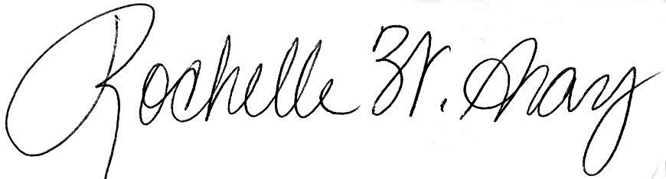
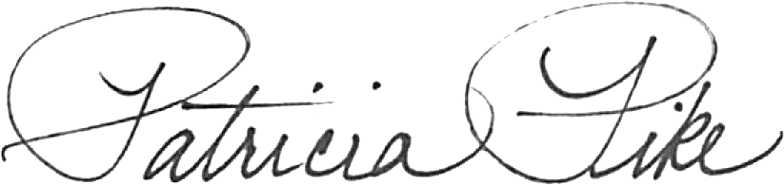

Representative Patricia Pike Representative Rochelle Gray
Scholarship Co-Chair Scholarship Co-Chair
District 126 District 081
816-751-5388 573-751-5538

Women Legislators of Missouri 2015 Scholarship Application
(Eight scholarships will be awarded to a female 2015 Missouri Graduating High School Senior)
Submission POSTMARK DEADLINE: March 19, 2015; please submit via postal service or email to:
Representative Patricia Pike, Missouri State Capitol, 201 W Capitol Ave, Jefferson City, MO 65101; or email to patricia.pike@house.mo.gov with the words WLM Essay Contest in the subject line.
Attention: Fill the form out completely and follow directions thoroughly so that you are not disqualified.

Applicant’s Personal Information:

MO House of Representatives District#____________ U.S. Congressional District#______
(Visit www.house.mo.gov and use the Legislator Look-Up to find the above information)

Name: _______________________________________________________ Age:___________________

Street Address: _____________________________________________ City: ____________________, MO

Zip: ________-_____ (+4) (use: www.usps.com to look up your 4-digit zip code)

Name of Parent or Guardian: _____________________ Parent or Guardian phone: (___)____________

Name of High School Counselor:____________________________ E-Mail Address: _________________

High School or GED Program currently enrolled: ______________________________________________
Cumulative GPA: _______________________ (Winners’ GPA may be verified by the Committee.)

To which colleges, universities, or vocational-technical schools have you already or plan to apply for admittance?
______________________________________________________________________________________

______________________________________________________________________________________

What area(s) of post-secondary education are you pursuing? ____________________________________
What are your current college-degree plans? _________________________________________________

Leadership (you may use separate sheet and attach to application) List those work experience, volunteer and extracurricular activities in which you took a leadership role: _________________________________

______________________________________________________________________________________

Community Service (you may use separate sheet and attach to application) List the extracurricular, community and volunteer activity programs in which you are or have been involved.

______________________________________________________________________________________

______________________________________________________________________________________
Essay Subject (500-word limit): As women legislators, we are honored and privileged to serve the people of Missouri. If you were a state legislator, what would you hope to accomplish and why?

